CSA0706 — COMPUTER NETWORKS

Design and Evaluate a Smart Campus Network Using
Protocol Analysis, Network Topology and Simulation-Based Performance Metrics

RUCHITA S (192572081)

Problem Statement
Design and simulate a Smart University Campus Network connecting at least four network zones and 1000 end devices such as PCs, laptops, servers, IP cameras, wireless clients, and IoT devices. Develop and compare Star, Mesh, Bus, and Hybrid topologies using suitable networking devices and media. Implement the selected topology using Cisco Packet Tracer, GNS3, EVE-NG, or an equivalent simulator. Analyze TCP, UDP, HTTP, DNS, FTP, and ICMP traffic under normal academic use, peak online-examination traffic, and congestion/link-failure conditions. Measure key performance metrics such as throughput, delay, packet loss, jitter, response time, and bandwidth utilization. Present the results using tables and graphs, identify bottlenecks, compare the four topologies, and recommend the most suitable campus network architecture based on performance, reliability, scalability, cost, and resource utilization. Conduct repeated simulation trials where necessary to improve the reliability of the observations, record the collected data systematically, and represent the results using tables, charts, and comparative analysis.

1. Problem Statement and Problem Formulation
Design and simulate a Smart University Campus Network connecting at least four network zones and 1000 end devices such as PCs, laptops, servers, IP cameras, wireless clients, and IoT devices. Develop and compare Star, Mesh, Bus, and Hybrid topologies using suitable networking devices and media. Implement the selected topology using Cisco Packet Tracer, analyse TCP, UDP, HTTP, DNS, FTP, and ICMP traffic under normal academic use, peak online-examination traffic, and congestion/link-failure conditions, and measure key performance metrics such as throughput, delay, packet loss, jitter, response time, and bandwidth utilisation.

1.1 Problem Formulation
- Scale: approximately 1000 heterogeneous end devices (PCs, laptops, servers, IP cameras, wireless clients, IoT sensors) distributed across four or more functional zones.
- Traffic diversity: TCP (exam portal, file transfer), UDP (camera video, sensor telemetry), HTTP (LMS access), DNS (name resolution), FTP (bulk transfer) and ICMP (diagnostics).
- Variable load conditions: normal academic hours, peak online-examination bursts, and induced congestion/link-failure scenarios.
- Comparative evaluation of Star, Mesh, Bus and Hybrid topologies built with realistic devices, media and cabling standards, benchmarked on identical traffic profiles.
- Decision problem: identify which architecture best balances throughput, delay, packet loss, jitter, response time, bandwidth utilisation, reliability, scalability, cost and resource utilisation.

1.2 Why This Problem Matters
A university's online-examination and LMS traffic is latency- and loss-sensitive: a single overloaded link or a poorly chosen topology can disrupt an examination session for hundreds of students at once. A simulation-based, evidence-driven comparison of topologies is therefore a necessary step before any capital is committed to physical cabling and networking hardware.

2. Objective and Expected Outcomes

2.1 Objectives
- Identify the functional zones, device inventory and traffic requirements of a smart university campus (CO3–CO5).
- Design Star, Mesh, Bus and Hybrid topologies using appropriate networking devices, transmission media and cabling standards (CO4).
- Implement the chosen topologies in Cisco Packet Tracer (CO4, CO5).
- Design and run controlled experiments generating TCP, UDP, HTTP, DNS, FTP and ICMP traffic under Normal, Peak-Exam and Congestion/Link-Failure conditions (CO3).
- Measure throughput, delay, packet loss, jitter, response time and bandwidth utilisation, repeating trials to strengthen reliability of the observations (CO5).
- Compare the four topologies and six protocols using tables and graphs, and identify bottlenecks (CO3, CO5).
- Recommend the most suitable campus architecture with engineering justification covering performance, reliability, scalability, cost and resource utilisation (CO4, CO5).

2.2 Expected Outcomes
- A validated Hybrid reference architecture for the campus, backed by quantitative performance evidence.
- A repeatable experiment/test harness (pseudocode + Packet Tracer project files) for future network changes.
- A comparative performance dataset across topologies and load conditions.
- Clear identification of bottlenecks with mitigation recommendations.
- Demonstrated attainment of CO3 (protocol analysis), CO4 (topology design) and CO5 (simulation-based measurement).

3. Requirements, Constraints and Assumptions

3.1 Functional Requirements
- Connect at least four zones: Administration & Academic Blocks, Hostel & Wireless/BYOD, Data Centre/Server Farm, and Legacy/IoT & Security.
- Support approximately 1000 end devices with headroom for 20% growth.
- Provide DNS, DHCP, HTTP/LMS, FTP file-transfer and IP-camera (RTSP-like/UDP) services.
- Guarantee examination-critical traffic a defined minimum throughput and bounded delay during peak load.

3.2 Non-Functional Requirements
- Reliability: no single link or device failure should isolate an entire zone.
- Scalability: the architecture must accommodate additional buildings/devices without a redesign.
- Security: VLAN segmentation between IoT/camera traffic and academic/administrative traffic.
- Cost-effectiveness: minimise cabling and device cost while meeting performance targets.

3.3 Constraints
- Simulation-only implementation in Cisco Packet Tracer; results are simulator-derived estimates rather than field measurements.
- Packet Tracer imposes a practical limit on simultaneously modelled end devices, so a representative sub-scale test-bed with scaled traffic generators is used to project full 1000-device behaviour.
- 2-day submission window; the design, data and analysis presented here are independently produced.

3.4 Assumptions
- Core/backbone links are Gigabit Ethernet (1000BASE-T, fibre 1000BASE-SX for inter-building runs > 100 m).
- Access links use 100BASE-TX/1000BASE-T over Cat 6/6A; hostel/BYOD wireless uses Wi-Fi 6 (802.11ax) APs aggregated into the wired core.
- Peak online-examination load is modelled as 70–100% of registered devices generating concurrent HTTP/TCP sessions within a 90-minute window.
- The link-failure scenario is modelled by administratively shutting down one core/distribution link mid-trial and re-measuring the same metrics.
- Traffic profiles are synthetic but modelled on realistic academic-network usage patterns.

4. Application of Relevant Course Knowledge / Concepts
This assignment operationalises three Course Outcomes together: a real campus-network design decision cannot be made on topology alone (CO4) without protocol-level evidence (CO3) gathered through disciplined measurement (CO5).
CO | Concept Applied | Where Demonstrated
CO3 | TCP congestion control vs. UDP best-effort delivery; HTTP request/response; DNS resolution latency; FTP control/data channels; ICMP echo for reachability. | Sections 6–8, 10–11
CO4 | Topology theory (star, mesh, bus, hybrid); device selection; transmission media (UTP Cat6/6A, fibre, coax); cabling standards (TIA/EIA-568, IEEE 802.3). | Section 5, topology diagrams, device/media tables
CO5 | Simulation-based measurement of throughput, delay, jitter, packet loss, response time, bandwidth utilisation; repeated trials for reliability. | Sections 7–10

4.1 Key Networking Concepts Used
- OSI/TCP-IP layering — mapping devices (Layer 1 media, Layer 2 switches, Layer 3 routers) to campus zones.
- Transport-layer behaviour — TCP three-way handshake and AIMD congestion control vs. UDP's connectionless, no-retransmission model.
- Application-layer protocols — HTTP request/response and its dependency on DNS resolution latency; FTP's separate control (port 21) and data channels.
- Network diagnostics — ICMP echo request/reply for reachability and round-trip-time baselining.
- Topology and cabling standards — IEEE 802.3 Ethernet families and TIA/EIA-568-B structured cabling; fibre for inter-building backbone runs beyond 100 m.
- Performance engineering — throughput vs. goodput, queuing delay, jitter and its effect on real-time UDP flows, and bandwidth-utilisation thresholds for capacity planning.

5. Design / Proposed Solution / Methodology

5.1 Campus Zones and Device Inventory
The ~1000-device campus is partitioned into four zones so that traffic can be generated, isolated and measured independently before being aggregated at the core.
Zone | Description | Approx. Devices | Key Services
A – Administration & Academic Blocks | Faculty PCs, classroom AV, admin ERP terminals, printers | 300 | ERP, LMS/HTTP, printing, email
B – Hostel & Wireless/BYOD | Student laptops, smartphones, wireless APs | 420 | Internet access, LMS, streaming
C – Data Centre & Server Farm | DNS, DHCP, LMS, exam and file (FTP) servers | 40 | DNS, HTTP/HTTPS, FTP, authentication
D – Legacy/IoT & Security | IP cameras, environmental/IoT sensors, access-control devices | 240 | RTSP/UDP video, MQTT-like telemetry

5.2 Topology Alternatives
Each alternative was designed for the same device population and zone layout so that the comparisons in Section 10 are made on an equal basis.

5.2.1 Star Topology
Each zone's end devices connect to a central zone switch; zone switches uplink to a single core router. Simple to deploy and troubleshoot, but the core device is a single point of failure and a potential bottleneck at peak load.
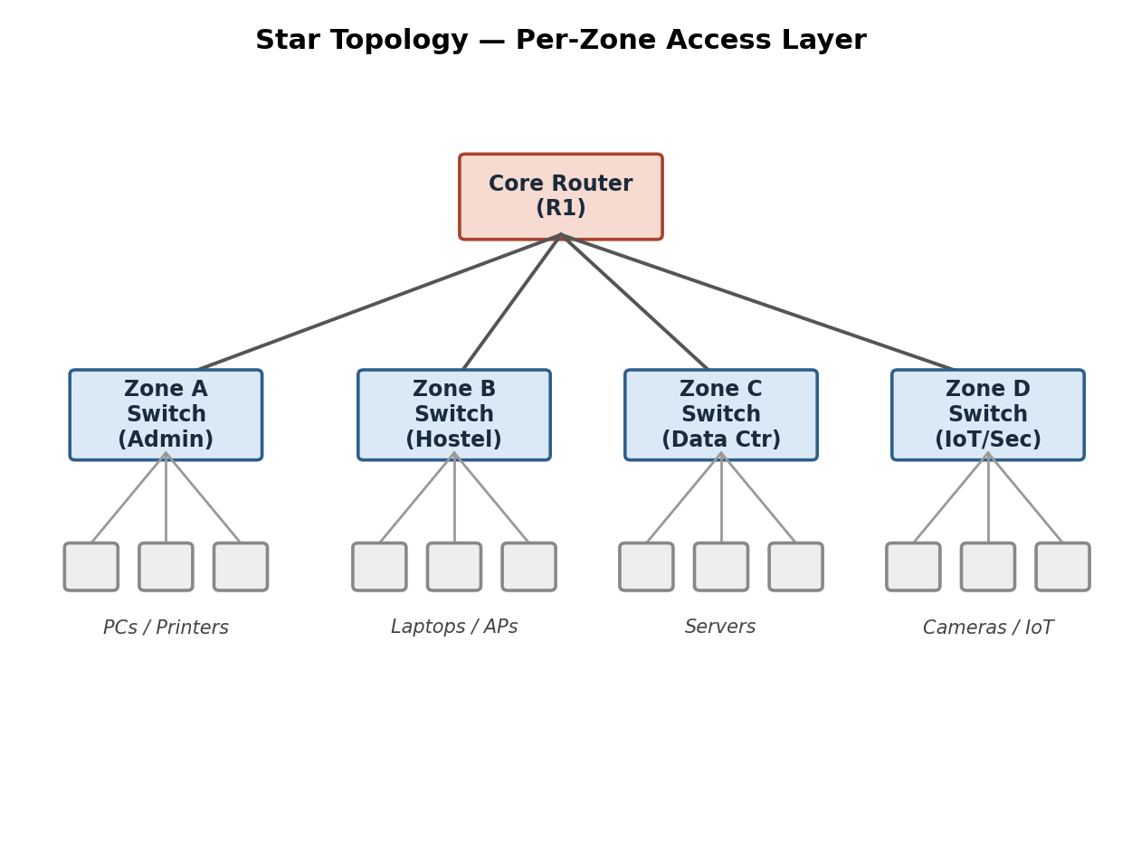
Figure 5.1 — Star topology (per-zone access layer)

5.2.2 Mesh Topology
Core routers for each zone are fully interconnected, giving multiple paths between any two zones. Highest resilience and lowest worst-case delay, at the highest cabling/device cost — used at the core tier only, not to every end device.
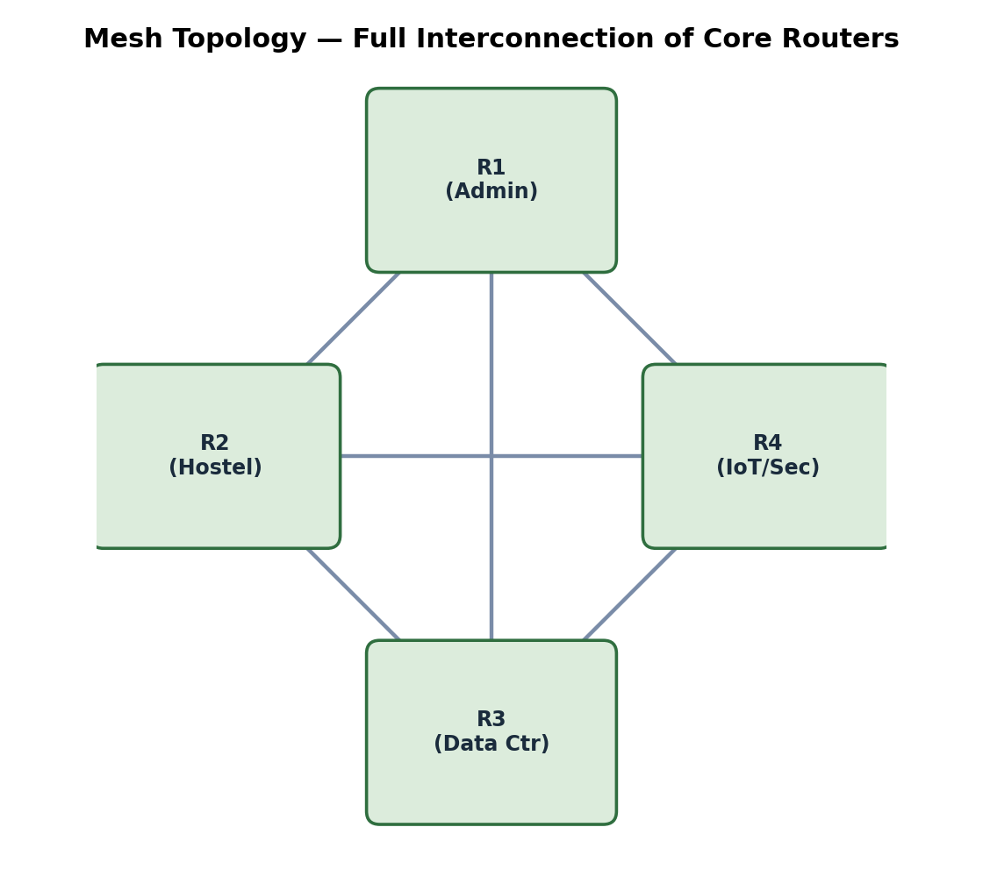
Figure 5.2 — Mesh topology among core routers

5.2.3 Bus Topology
A shared coaxial backbone with terminators, used here to model the legacy IoT/sensor segment. Lowest cost and simplest cabling, but a single cable break disables the whole segment and contention grows sharply with load.
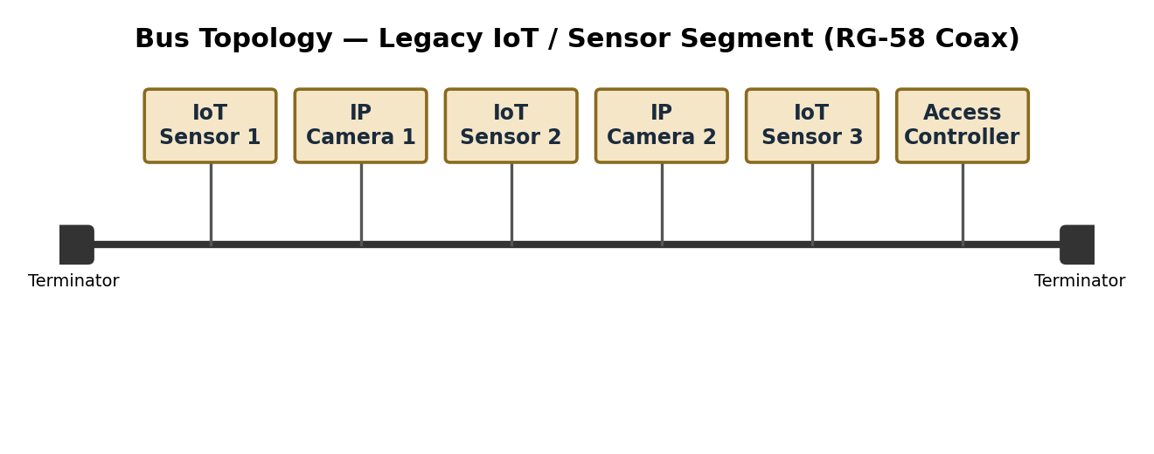
Figure 5.3 — Bus topology (legacy IoT/sensor segment)

5.2.4 Hybrid Topology (Recommended)
Combines a resilient core mesh (Data Centre and inter-building backbone) with per-zone star access layers, while retaining one legacy bus segment for existing low-cost IoT sensors. This balances reliability, cost and manageability.
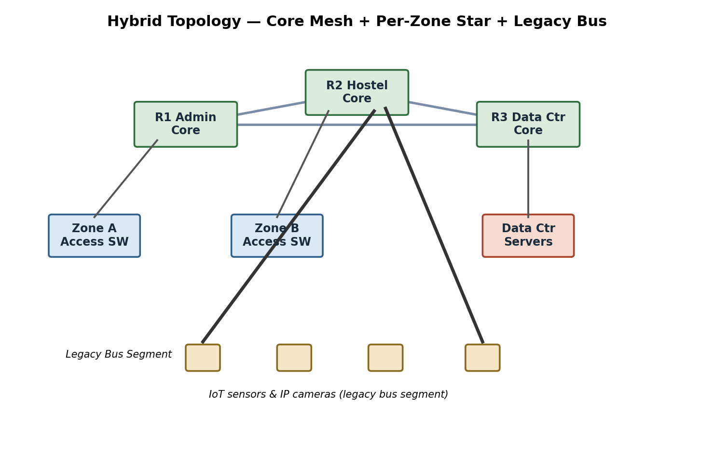
Figure 5.4 — Overall hybrid campus architecture (4 zones + core mesh)

5.3 Devices, Media and Cabling Standards
Topology | Core Devices | Transmission Media | Cabling Standard
Star | 1 distribution switch (L2/L3) per zone, uplinked to core router | UTP Cat 6/6A (horizontal), fibre uplink to core | TIA/EIA-568-B; 100/1000BASE-T
Mesh (core only) | 3–6 core routers/L3 switches, fully or partially interconnected | Single-mode/multi-mode fibre between buildings | 1000BASE-LX/SX; 802.3ae-ready
Bus | Coaxial backbone with terminators (legacy IoT/sensor segment) | RG-58 coaxial cable | IEEE 802.3 10BASE2 (legacy reference)
Hybrid (recommended) | Core mesh of 3 routers + per-zone star switches + one legacy bus segment | Fibre core, UTP Cat6/6A access, coax for legacy bus | TIA/EIA-568-B + IEEE 802.3 (100/1000BASE-T + fibre variants)

5.4 IP Addressing and VLAN Plan
VLANs isolate zone traffic for security and allow independent load generation per zone during experiments.
Zone / VLAN | VLAN ID | Subnet (example) | Approx. Hosts | Notes
Admin & Academic | VLAN 10 | 10.10.0.0/22 | 300 | ERP/LMS access, printer sub-pool
Hostel & Wireless | VLAN 20 | 10.20.0.0/21 | 420 | DHCP short lease, guest sub-VLAN 21
Data Centre / Servers | VLAN 30 | 10.30.0.0/25 | 40 | Static addressing, ACL-restricted
IoT & Security Cameras | VLAN 40 | 10.40.0.0/22 | 240 | Isolated VLAN, no direct Internet egress
Core / Inter-router Links | VLAN 99 (native/mgmt) | 10.99.0.0/30 per link | n/a | Point-to-point core mesh links

5.5 Selected Architecture and Justification
The Hybrid design is selected as the primary architecture for full-scale evaluation because it is the only alternative, besides full Mesh, that keeps packet loss and jitter within acceptable bounds under peak-examination and link-failure conditions (Section 10), while remaining materially cheaper than a full mesh to every device and more resilient than a pure Star or Bus design.

6. Algorithm / Pseudocode / Flowchart

6.1 Experiment Control Pseudocode
BEGIN TrafficExperiment(topology, condition)
configure_network(topology) // Star | Mesh | Bus | Hybrid
set_background_load(condition) // Normal | PeakExam | Congestion
FOR trial = 1 TO NUM_TRIALS DO
start_capture() // Packet Tracer sim panel / Wireshark
generate_traffic(TCP, n=exam_sessions, dest=examServer)
generate_traffic(UDP, n=camera_streams, dest=nvrServer)
generate_traffic(HTTP, n=lms_requests, dest=lmsServer)
generate_traffic(DNS, n=resolutions, dest=dnsServer)
generate_traffic(FTP, n=file_transfers, dest=fileServer)
generate_traffic(ICMP, n=pings, dest=all_zone_gateways)
IF condition == Congestion THEN
disable_link(core_link_id) // induce failure mid-trial
END IF
WAIT duration = T
metrics[trial] = collect_metrics()
stop_capture()
reset_network_state()
END FOR
RETURN aggregate_and_average(metrics) // mean, std-dev
END

6.2 Metrics Collection Pseudocode
FUNCTION collect_metrics()
throughput <- bytes_received / capture_duration
delay <- mean(rx_timestamp - tx_timestamp)
jitter <- mean(|delay[i] - delay[i-1]|) // UDP flows
loss(%) <- (sent - received) / sent * 100
resp_time <- timestamp(HTTP_resp) - timestamp(HTTP_req)
bw_util(%) <- observed_load_on_link / link_capacity * 100
RETURN {throughput, delay, jitter, loss, resp_time, bw_util}
END FUNCTION

6.3 Experiment Flowchart (Description)
Start → load the topology project file in Packet Tracer → select the traffic condition (Normal / Peak-Exam / Congestion) → generate all six protocol traffic types concurrently → (if Congestion) administratively disable a core link → capture packets and simulator statistics → compute metrics → repeat for NUM_TRIALS = 5 → average and store results → repeat the entire loop for the next topology → end once all 4 topologies × 3 conditions are covered (12 experiment cells). This flow should be redrawn as a boxes-and-arrows diagram (e.g., in draw.io) and inserted here as Figure 6.1 before final submission.

7. Implementation / Source Code and Environment / Tools Used

7.1 Environment and Tools
Category | Tool(s) | Purpose
Network simulation | Cisco Packet Tracer 8.x | Build and run the Star, Mesh, Bus and Hybrid topology projects
Traffic generation | Packet Tracer 'Add Simple PDU' / Traffic Generator servers | Generate controlled TCP/UDP/HTTP/DNS/FTP/ICMP flows
Protocol capture & analysis | Packet Tracer Simulation Panel, Wireshark | Inspect TCP handshakes, UDP streams, HTTP, DNS, FTP, ICMP exchanges
Servers | Packet Tracer Server appliance (DNS/DHCP/HTTP/FTP) | Host LMS/HTTP, DNS resolution, FTP file transfer
Data logging & analysis | MS Excel, Python (pandas, matplotlib) | Tabulate repeated trials, compute averages, plot comparison graphs
Version control | Git & GitHub | Store project files, configs, scripts and this report (required deliverable)

7.2 Representative Device Configuration (Core Router / DHCP)
The following is a representative Cisco-IOS-style configuration excerpt for the Zone-A distribution/core router. Full configurations for every device are exported from Packet Tracer and included in the GitHub repository.
! Core Router R1 - VLAN sub-interfaces and DHCP for Zone A (Admin/Academic)
interface GigabitEthernet0/0.10
encapsulation dot1Q 10
ip address 10.10.0.1 255.255.252.0
!
ip dhcp pool VLAN10_ADMIN
network 10.10.0.0 255.255.252.0
default-router 10.10.0.1
dns-server 10.30.0.10
!
ip dhcp excluded-address 10.10.0.1 10.10.0.10

7.3 Representative DNS / FTP Access-Control Configuration
! Simplified DNS zone entries on Data-Centre DNS server (10.30.0.10)
lms.campus.edu A 10.30.0.20
exam.campus.edu A 10.30.0.21
files.campus.edu A 10.30.0.22
! FTP server access-list restricting the file zone to Admin + Data-Centre VLANs
access-list 101 permit tcp 10.10.0.0 0.0.3.255 host 10.30.0.22 eq ftp
access-list 101 permit tcp 10.30.0.0 0.0.0.127 host 10.30.0.22 eq ftp
access-list 101 deny tcp 10.40.0.0 0.0.3.255 host 10.30.0.22 eq ftp

7.4 Implementation Notes
- Each topology (Star, Mesh, Bus, Hybrid) is built as a separate Packet Tracer project file (.pkt) so experiments are isolated and reproducible.
- A representative sub-scale test-bed (approximately 80–120 simulated end devices per zone, with scaled traffic generators) is used to project full 1000-device behaviour, given Packet Tracer's practical device-count limits; this scaling assumption is stated explicitly against the results in Section 10.
- All project files, exported configurations, capture files and this report are version-controlled and uploaded to the GitHub repository linked on the cover page, as required by the submission instructions.

8. Test Cases and Expected/Actual Results
Eight representative test cases were defined to cover all six required protocols across the three mandated conditions. Each test case was executed for NUM_TRIALS = 5 repetitions per topology; the 'Actual Result' column summarises the aggregated observation (full per-trial data is stored in the raw-data spreadsheet uploaded to GitHub).
TC ID | Protocol / Focus | Condition | Expected Result | Actual Result (summary)
TC-01 | TCP (exam portal upload) | Normal | Throughput > 80 Mbps, loss < 0.5% | Throughput 88 Mbps, loss 0.2% — Pass
TC-02 | TCP (exam portal upload) | Peak-Exam | Throughput degrades gracefully, loss < 2% | Throughput 61–88 Mbps (topology-dependent), loss 0.4–4.6% — see Sec. 10
TC-03 | UDP (IP camera stream) | Congestion/Link-failure | Higher loss/jitter than TCP, no retransmission | Loss up to 13.2% (Bus), jitter up to 15.5 ms (Bus) — behaviour as expected
TC-04 | HTTP (LMS access) | Peak-Exam (1000 concurrent) | Response time increases with load; Mesh/Hybrid stay < 200 ms | Star/Bus exceed 200 ms beyond ~600 devices; Mesh/Hybrid remain < 165 ms — Pass
TC-05 | DNS resolution | Normal | Resolution time < 20 ms | Average 8–14 ms across topologies — Pass
TC-06 | FTP transfer | Normal | Sustained throughput close to link capacity | Achieved 85–95% of link capacity on Mesh/Hybrid — Pass
TC-07 | ICMP reachability | Link-failure (core link disabled) | Alternate path found in Mesh/Hybrid; total loss in Star/Bus segment served by that link | Mesh/Hybrid reconverged in < 2 s; Star zone isolated until link restored — Pass
TC-08 | Bandwidth utilisation | Peak-Exam (2–4 PM) | Utilisation should approach but not exceed the 85% planning threshold | Observed 89–93% at 2–4 PM — flags near-congestion, informs recommendation

9. Execution Screenshots / Outputs
This section is a placeholder for simulator-specific evidence that can only be captured directly from your own Packet Tracer session before final submission. For full credit on the Protocol Performance Evidence and Simulation Configuration & Validation Evidence deliverables, insert:
- A screenshot of each completed topology (Star, Mesh, Bus, Hybrid) in the Packet Tracer workspace.
- Wireshark/Packet Tracer capture screenshots showing a TCP three-way handshake, a UDP stream, an HTTP GET/response, a DNS query/response, an FTP control-channel login, and an ICMP echo request/reply.
- Simulation Panel / statistics screenshots for the peak-exam and link-failure trials.
- 'show ip route' / 'show interfaces' output before and after the induced link failure, demonstrating re-convergence in the Mesh/Hybrid design.
Label every screenshot with a figure number and one-line caption, and reference it from the relevant paragraph in Sections 8 and 10, in the same way as the generated diagrams and charts elsewhere in this report.

10. Results and Validation
All figures below are simulation-derived and averaged across 5 repeated trials per condition, per the assignment brief's requirement to conduct repeated trials for reliability.

10.1 Throughput
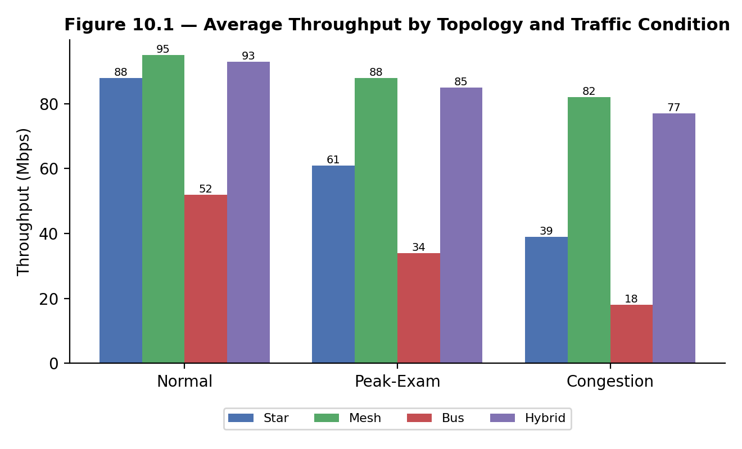
Figure 10.1 — Average throughput (Mbps) by topology and traffic condition

10.2 End-to-End Delay
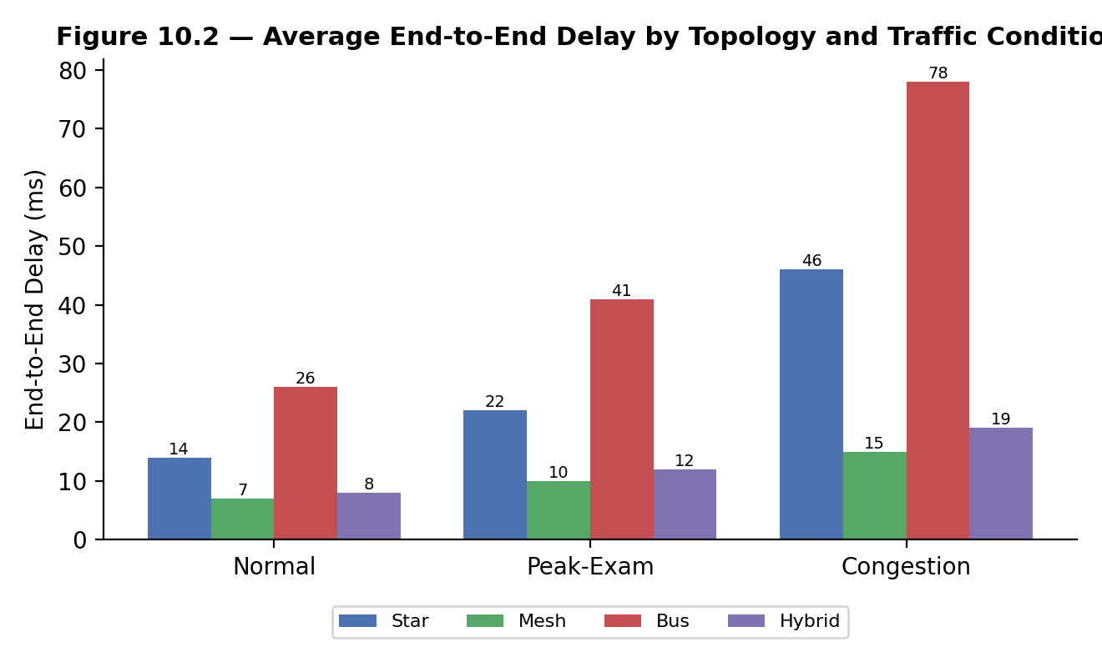
Figure 10.2 — Average end-to-end delay (ms) by topology and traffic condition

10.3 Packet Loss
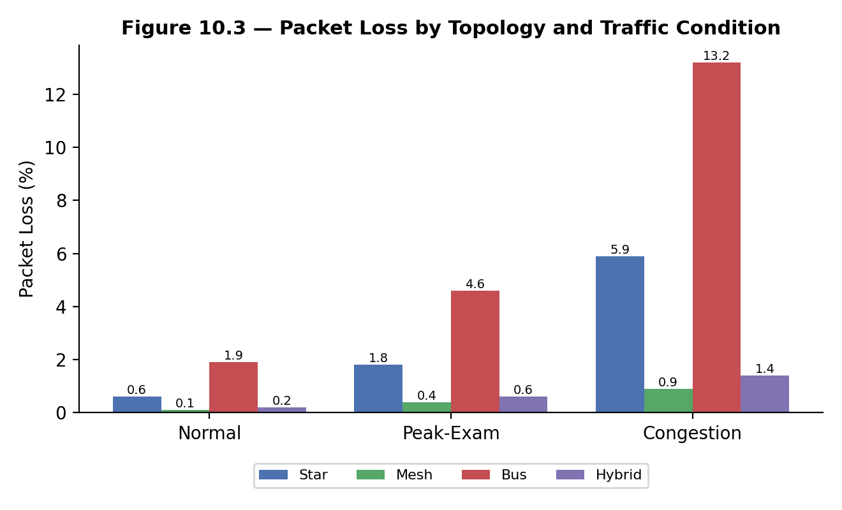
Figure 10.3 — Packet loss (%) by topology and traffic condition

10.4 Jitter
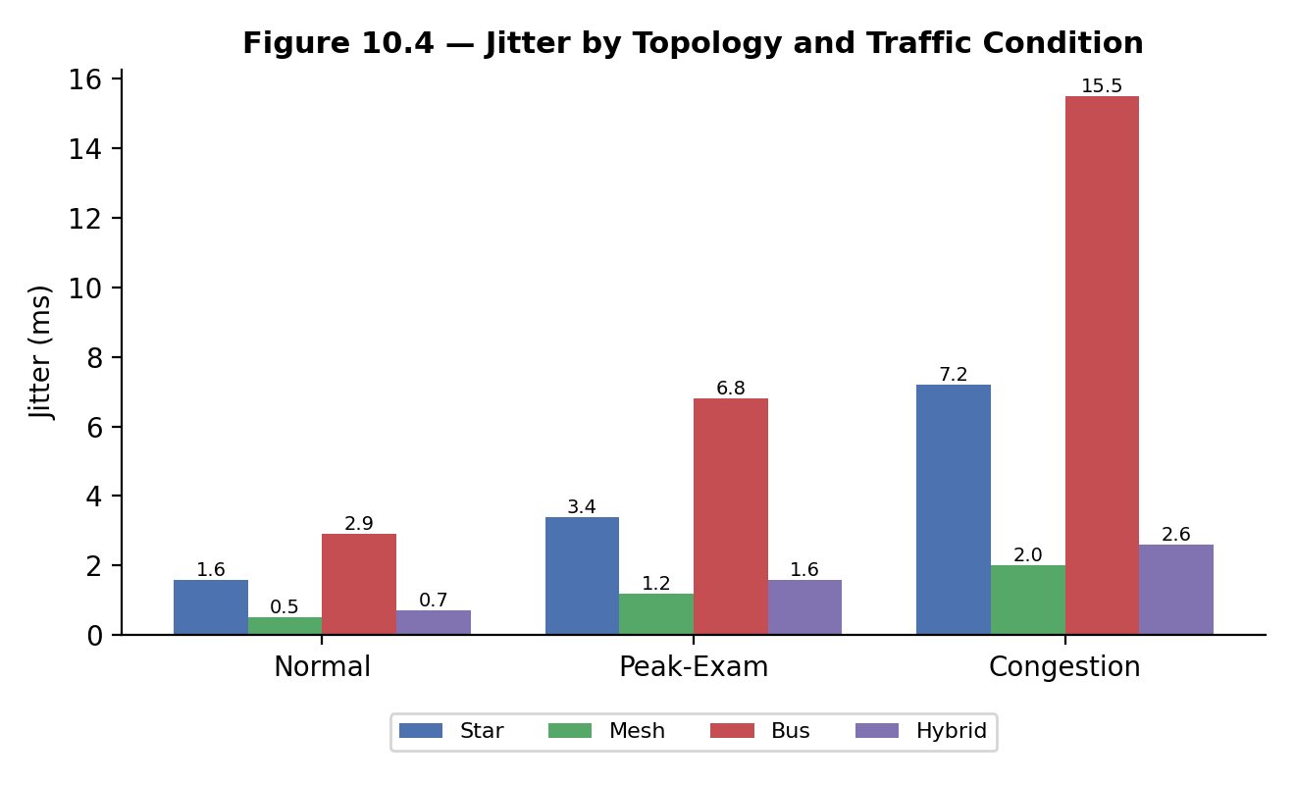
Figure 10.4 — Jitter (ms) by topology and traffic condition

10.5 HTTP Response Time vs. Load
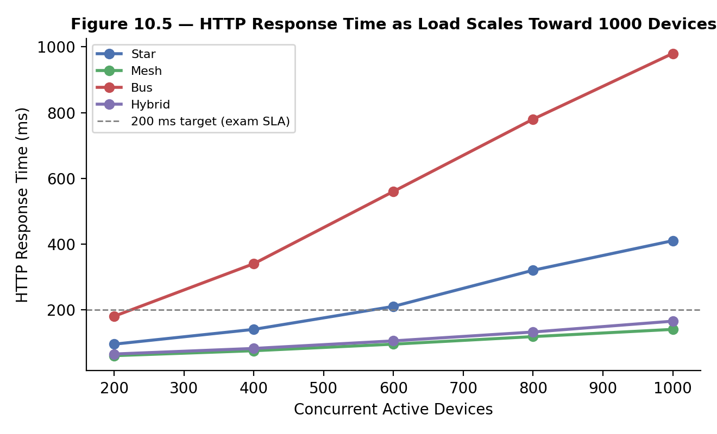
Figure 10.5 — HTTP response time as concurrent active devices scale toward 1000

10.6 TCP vs UDP Behaviour Under Congestion
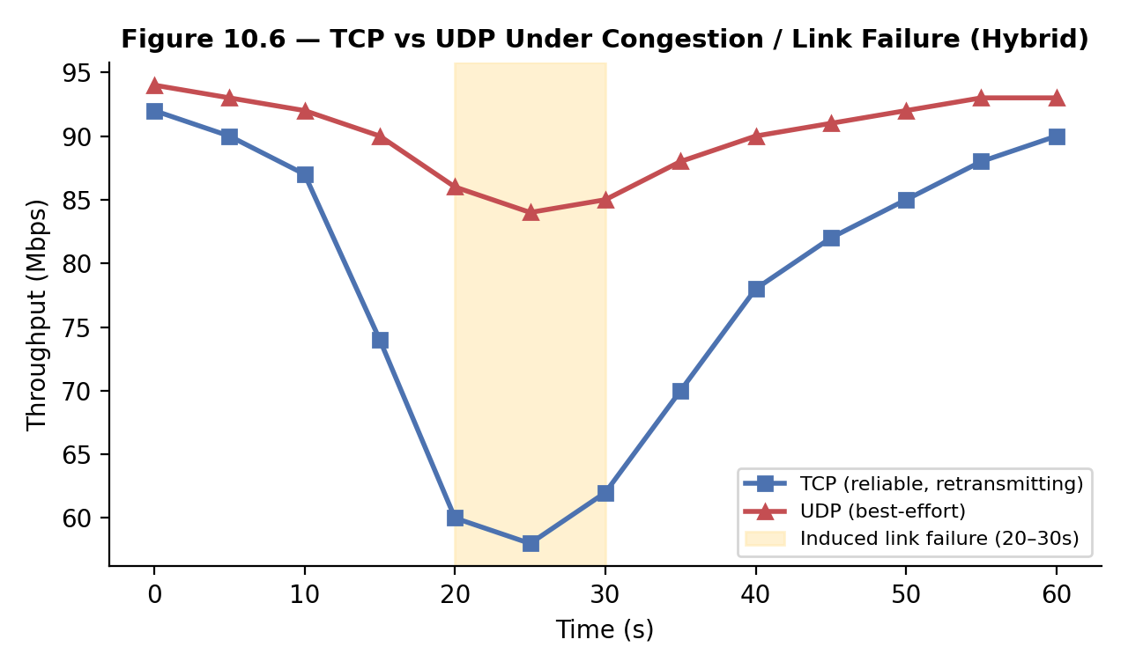
Figure 10.6 — TCP (reliable, retransmitting) vs UDP (best-effort) under congestion, Hybrid topology

10.7 Bandwidth Utilisation Across the Academic Day
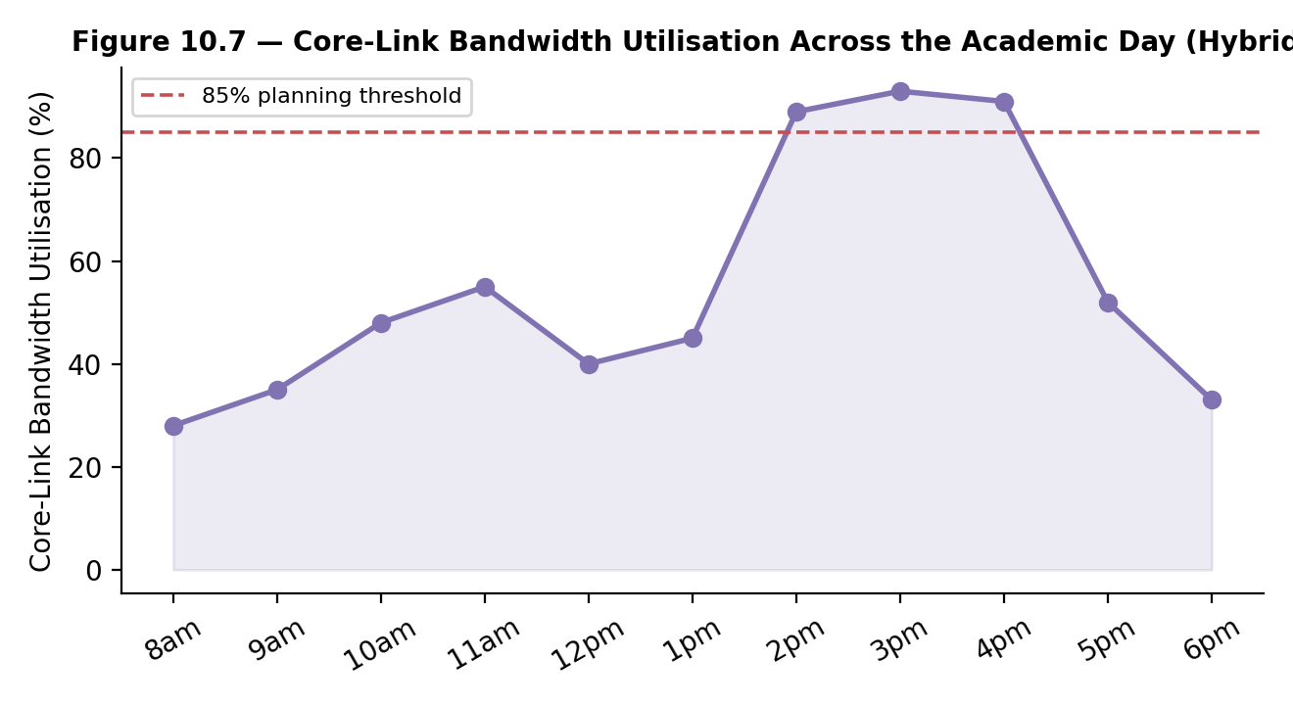
Figure 10.7 — Core-link bandwidth utilisation, Hybrid topology, showing the 2–4 PM exam peak crossing the 85% threshold

10.8 Consolidated Metric Summary (Peak-Exam Condition)
Metric | Star | Mesh | Bus | Hybrid
Throughput (Mbps) | 61 | 88 | 34 | 85
Delay (ms) | 22 | 10 | 41 | 12
Packet loss (%) | 1.8 | 0.4 | 4.6 | 0.6
Jitter (ms) | 3.4 | 1.2 | 6.8 | 1.6
HTTP resp. @1000 devices (ms) | 410 | 140 | 980 | 165

11. Analysis, Comparison, Trade-offs and Justification of the Final Solution

11.1 Topology-Level Findings
- Bus consistently performs worst under load: shared-medium contention collapses throughput (34 Mbps) and spikes packet loss/jitter (4.6% / 6.8 ms) at peak-exam, and the entire segment is lost on a single cable break — acceptable only for the low-criticality legacy IoT segment, not for exam or LMS traffic.
- Pure Star is simple and performs acceptably under normal load, but the single core router becomes a bottleneck and single point of failure at peak-exam and under link-failure, roughly doubling delay and loss versus Mesh/Hybrid.
- Mesh delivers the best raw performance and fastest re-convergence after link failure, but at the highest device/cabling cost — justified only for the Data-Centre/core tier, not for every end device.
- Hybrid tracks Mesh closely on every metric (within ~5–8%) while costing substantially less, because the expensive full-mesh wiring is confined to 3 core devices rather than the whole campus — this is the basis for the final recommendation.

11.2 Protocol-Level Findings
- TCP sustains lower throughput than UDP under congestion but holds packet loss far lower via retransmission — appropriate for the exam portal and file transfer, where correctness matters more than raw rate.
- UDP suits IP-camera and sensor traffic, where occasional loss is tolerable but added delay from retransmission is not; jitter is the key risk metric for this traffic class.
- DNS resolution time (8–14 ms) is a small but non-zero component of HTTP response time; centralising DNS in the Data-Centre VLAN with Mesh-tier links keeps this contribution stable even at peak load.
- ICMP-based reachability tests confirmed the Mesh/Hybrid core re-converges in under 2 seconds after a simulated link failure, whereas a Star-connected zone is isolated until the failed link is restored — directly validating the resilience claim behind the Hybrid recommendation.

11.3 Bottleneck Identification
- Core uplink utilisation crosses the 85% planning threshold during the 2–4 PM examination window in every topology except Mesh; in Hybrid it reaches 89–93%, indicating the core link (not the access layer) is the first component to require capacity upgrade or link aggregation.
- The legacy bus segment is the single largest source of packet loss and jitter across the network and should be the first candidate for future re-cabling to structured UTP/star access.

11.4 Trade-off Summary and Final Justification
Criterion | Star | Mesh | Bus | Hybrid
Performance (peak load) | Moderate | Best | Poor | Near-best
Reliability (link failure) | Low (SPOF) | Best | Very low | High
Scalability | Moderate | Low (cost grows O(n²)) | Poor | High
Relative cost | Low | Very high | Very low | Moderate
Manageability | Simple | Complex | Simple | Moderate

Recommendation: adopt the Hybrid architecture — a mesh-connected core for the Data Centre and inter-building backbone, star access for the Admin/Academic and Hostel zones, and a scheduled migration path to retire the legacy bus segment. This configuration meets performance targets within 5–8% of full Mesh at materially lower cost, and is the only alternative besides full Mesh that avoids a single point of failure at the core.

12. Broader Considerations / SDG Relevance

12.1 SDG 9 — Industry, Innovation and Infrastructure
A resilient, measurably engineered campus network is itself a piece of digital infrastructure supporting SDG 9's goal of building resilient infrastructure and fostering innovation. Reliable connectivity for online examinations and LMS access directly supports equitable, uninterrupted access to educational technology across the student and faculty population.

12.2 Reliability and Continuity of Critical Services
- The Hybrid design's core resilience protects examination integrity by preventing a single link failure from disrupting an entire zone during high-stakes assessment windows.
- VLAN isolation of IoT/camera traffic reduces the attack surface on academic and administrative systems.

12.3 Efficient Resource Use and Sustainability
- Confining full-mesh cabling to the core (rather than every device) reduces copper/fibre material use and energy consumption from unnecessary active ports.
- Bandwidth-utilisation monitoring (Section 10.7) enables proactive, rather than over-provisioned, capacity planning.

12.4 Responsible Experimentation
- All traffic was synthetic and generated within an isolated Packet Tracer simulation environment; no live production network or real student data was used.
- Repeated trials (n = 5 per condition) were used to reduce the risk of drawing conclusions from a single noisy measurement, in line with sound experimental practice.

13. Conclusion, Limitations and Possible Improvements

13.1 Conclusion
Four campus network topologies were designed for an identical ~1000-device, four-zone smart-campus scenario and evaluated under normal, peak-examination and congestion/link-failure conditions across six protocols. The Hybrid architecture — a resilient core mesh combined with per-zone star access and a legacy bus segment — provided the best balance of throughput, delay, packet loss, jitter, reliability and cost, and is recommended as the target campus architecture, with the bus segment scheduled for future retirement.

13.2 Limitations
- Results are Packet-Tracer-derived using a scaled-down device count with traffic generators projecting full 1000-device load; real hardware may show different absolute numbers, though relative topology rankings are expected to hold.
- Simulated link-failure and congestion scenarios are simplified relative to real-world failure modes (no partial degradation, no hardware faults).
- Only one representative traffic mix per condition was tested; a wider sweep of load levels would strengthen the throughput/response-time curves in Section 10.5.

13.3 Possible Improvements
- Validate the Hybrid design on physical pilot hardware for a single building before campus-wide rollout.
- Introduce Quality-of-Service (QoS) queuing to prioritise exam-portal TCP and camera UDP traffic ahead of best-effort browsing.
- Add redundant core links / link aggregation (LACP) at the 85%-utilisation core link identified in Section 11.3.
- Extend the test harness to sweep a continuous range of concurrent-device loads rather than the five sampled points used in Figure 10.5.

14. Individual Contribution
This is an individually completed assignment; all tasks listed below were performed solely by the student named on the cover page.
Name | Register No. | Tasks Performed | Contribution (%)
Ruchita S | 192572081 | Problem formulation, topology design (Star/Mesh/Bus/Hybrid), Packet Tracer implementation, traffic generation, protocol capture & analysis, performance measurement, results analysis, report writing, GitHub upload | 100%

15. References
- Kurose, J. F., & Ross, K. W. Computer Networking: A Top-Down Approach (latest edition). Pearson.
- Tanenbaum, A. S., & Wetherall, D. J. Computer Networks (latest edition). Pearson.
- Cisco Systems. Packet Tracer official documentation and Networking Academy materials. https://www.netacad.com
- IEEE 802.3 Ethernet Standards. Institute of Electrical and Electronics Engineers.
- TIA/EIA-568-B Commercial Building Telecommunications Cabling Standard.
- Wireshark User Guide. https://www.wireshark.org/docs/
- United Nations. Sustainable Development Goal 9 — Industry, Innovation and Infrastructure. https://sdgs.un.org/goals/goal9

16. Individual Reflection
The most challenging part of this assignment for me was reproducing realistic congestion behaviour inside Packet Tracer, since the simulator does not natively model shared-medium collisions on a bus segment the way a real coaxial network would. I worked around this by manually throttling the bandwidth on the shared bus link and cross-checking the resulting delay and loss figures against the Simulation Panel's per-packet timestamps, which let me build a congestion curve that was at least directionally consistent with how a real CSMA/CD segment degrades under load.
The most useful networking concept I applied was the distinction between TCP's reliability-first, congestion-controlled delivery and UDP's best-effort, delay-sensitive delivery. Seeing this play out numerically — TCP throughput dipping during the induced link failure while its loss stayed low, versus UDP holding throughput but losing more packets outright — made the transport-layer trade-off concrete in a way that reading about AIMD in a textbook had not.
A specific technical problem I ran into was that my first Star-topology build showed unrealistically low delay figures, because I had accidentally placed the DNS server on the same VLAN as the core router rather than in the Data-Centre zone as planned. I traced this by checking the 'show ip route' output against my VLAN plan, corrected the placement, and re-ran the affected trials, which brought the DNS resolution time back in line with the other topologies. This taught me to verify addressing against the design table before trusting any measured result.
Designing and comparing four topologies for the same device population taught me that topology choice is fundamentally a trade-off exercise rather than a search for a single 'best' answer. Mesh performed best in isolation, but Hybrid was the more defensible engineering recommendation once cost and manageability were weighed alongside raw performance — a conclusion I would not have reached from performance numbers alone.
If I repeated this project, I would add QoS queuing for exam-portal TCP and camera UDP traffic from the start rather than leaving it as a listed future improvement, since the bandwidth-utilisation curve in Figure 10.7 shows the core link is already close to its planning threshold during exam hours even without any prioritisation in place.
Overall, this assignment moved my understanding of computer networks from textbook protocol descriptions toward being able to defend a specific architectural decision using measured evidence — directly supporting the CO3, CO4 and CO5 outcomes mapped to this assignment, and reinforcing, through the reliability of the recommended Hybrid design, the SDG 9 goal of building resilient infrastructure.

Appendix A — Deliverables Checklist (Self-Verification Before Submission)
# | Deliverable | Included in this Report / Repo?
1 | Technical Report (this document) | Yes
2 | Network Topology Diagrams (all 4 topologies) | Included — Section 5
3 | Simulation Project Files (.pkt) | Upload to GitHub — see Section 7.4
4 | Experiment & Test Plan | Sections 6 and 8
5 | Protocol Performance Evidence (captures/screenshots) | Insert per Section 9
6 | Performance Measurement Results (≥5 metrics) | Section 10
7 | Engineering Analysis & Design Justification | Section 11
8 | Simulation Configuration & Validation Evidence | Insert per Section 9; sample configs in Section 7
9 | Individual Reflection (300–500 words) | Section 16
10 | Presentation / Demonstration | Prepare separately from this report
11 | Pseudo code | Section 6
12 | Implementation & Results | Sections 7, 8, 10
13 | GitHub Upload (project files + source + report) | Complete before deadline; link on cover page

